 International Journal of Pharma and Bio Sciences

The following are the universities who have indexed and catalogued our journal

Embase (Elsevier) | EMBASE (Elsevier)
Index Copernicus | 
International Scientific Indexing | 
Crossref | 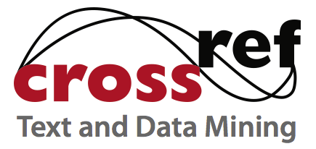
DOI | 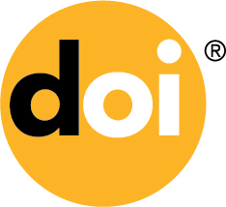
Google | 
Google Scholar | 
International committee of medical journal editors | 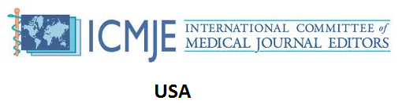
WorldCat | 
Citeseerx | 
EVISA | 
Fairfield University  (DiMenna-Nyselius Library) | 
Harper Adams University College | 
University of Bayreuth | 
University of Duisburg-Essen | 
University of Pittsburgh (University Library System) | 
Aberystwyth University | 
Adam State college | 
Alzheimer Research Forum | 
Auburn University Library | 
Central Connecticut State University (Elihu Burritt Library) | 
Chemical Abstracts Service (CAS) (USA) | 
Doshisha University | 
EBSCO | 
Gunma university | 
Hokkaido University | 
Huntington College - Houghton memorial library | 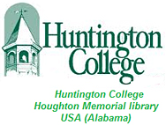
ILLINOIS state university  (Milner Library) | 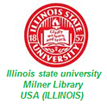
Jacksonville State University (Houston Cole Library) | 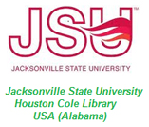
Lebanese American University  (LAU Libraries) | 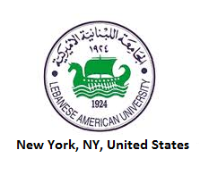
Lund University (Sweden) | 
Naropa University (Allen Ginsberg Library) | 
National Library of Sweden | 
Open j gate | 
Princeton University (USA) (Princeton university library) | 
ProQuest | 
Quinnipiac University  (Quinnipiac University Libraries) | 
Samford university library | 
SCIFinder | 
Spring Hill College (Marnie and john Burke memorial library) | 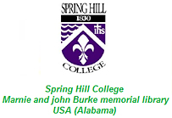
Ulrichs Directory of periodicals | 
University of Erlangen-Nuremberg | 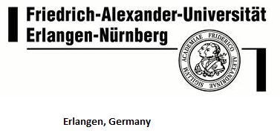
University of Oxford | 
University of Ozarks | 
University of Reading | 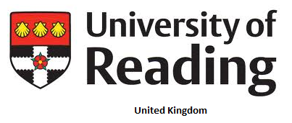
University of texas at Austin | 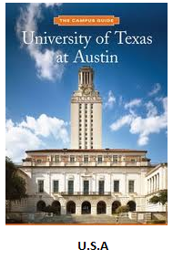
University of Minnesota | 

The above indexing status may change /updated in future which may or may not be reflected in this listing. Readers/Authors/Users can ensure by visiting/ communicating to the respective university / indexing body.

