Step 1: Kindly enter the following link in Google window.
https://www.crossref.org/06members/51depositor.html
Step 2 :
Search the journal name (International journal of pharma and bio sceinces) by using find box (ctrl +f)

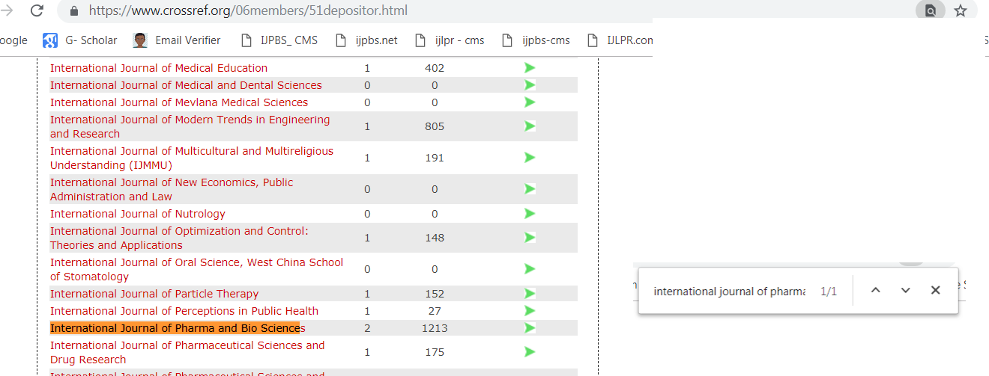
Step 3:
After searching the below result will be displayed
